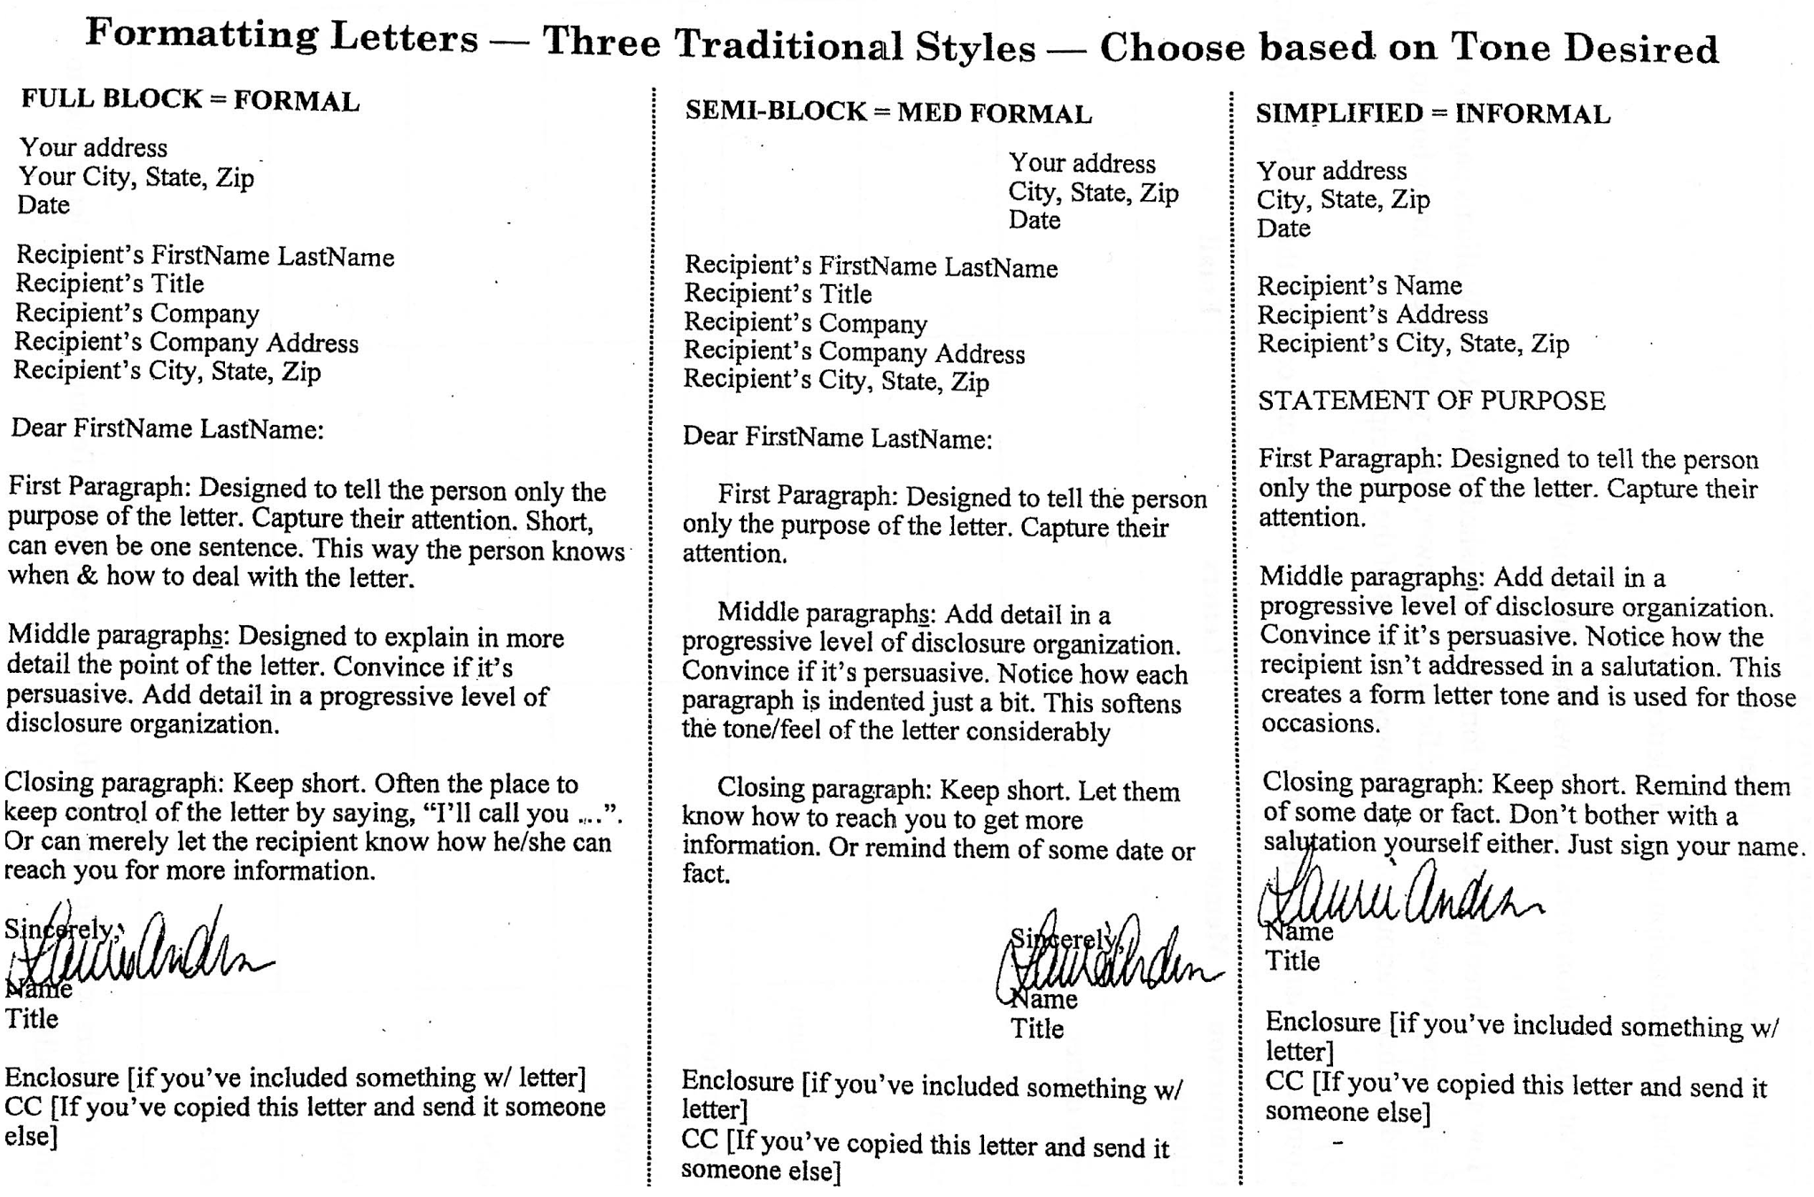

|  |  |  |  |
| --- | --- | --- | --- |
| **Comparison Criteria** | **Memos** | **Letters** | **Email** |
| Front Matter | To, CC, From, Date | Address, Date, First & Last, Title, Company, Company Address, Recipient Address | To, CC, Subject, From |
| End Matter | None | Sincerely, Signature, Name, Title, CC, Enclosures | Sincerely, Typed Name, Title |
| Authentication | Initials by name | Signature | Validity of senders email |
| Intro |  | Tell purpose (general), purpose intro | Summary Statement |
| Body | Pattern dependent | PLD | PLD |
| Conclusion |  | Reminder or next | Next Steps |
| Next Steps |  | Let them know how to reach you | Let me know if questions |

|  |  |  |  |  |  |  |
| --- | --- | --- | --- | --- | --- | --- |
| **Com Criteria** | **C/C Memo** | **Process** | **Instruction** | **Position** | **Letter** | **Problem Solution** |
| Pace | Med | Med | Fast | Med | Varies | Med |
| POV | Intro: 2nd and 3rd. Body: 3rd. Conc: 2nd, some 3rd | 2nd to refer to the reader | 2nd | 3rd | varies | 2nd |
| Purpose | Help reader make decision. | Explain why things are the way they are and background for use | Teach reader how to do something | Convince the reader to adopt thesis or claim | Formal communication | To solve a problem that the reader has |
| Tone | Formal | Formal | Formal, concise | Formal | Formal | Formal |
| **Com Criteria** | **C/C Memo** | **Process** | **Instruction** | **Position** | **Letter** | **Problem Solution** |
| Organize | **Memorandum**  **To:**  **From:**  **Date:**  **Subject:**  **Introduction**  **intro para:**  audience, decision,  subject(s),Criteria  **Comparison**  Table, p/p, w/w  **Conclusion:** One sentence restating subjects & criteria.  **Bulleted list if then --**Covers each criterion  **Recommendation**  **References**  **Word Count**  (side note: Criteria goes top left in table) | **Title of book**  **Chapter #& name**  **Author**  **Contents** Body of TOC  Para: this manual will help you.... to... by advising you on how to....  **H1 (ing words)**  1 sentence on why  **S1.(ing if possible)**  para on why  para on what is needed to do  no conclusion | **Title**  Purpose statement  **Stages and steps**  (stages break steps apart into sections)  **Error conditions** (CAUTION, WARNING, DANGER)  No conclusion | Introduction:  Para w/ problem to be addressed  Thesis at end    Body:  h1 heading  h1 one sentence:  i.g. this will result in... s1, s2, s3  **conclusion**:  para to bring the work to satisfactory end. do not summarize or try to persuade.  topic sentence is retell thesis, then tell what to do now via recommendation or call to action | front matter,  Intro,  pattern intro,  pattern body,  pattern conclusion, letter conclusion,  letter end matter | Intro: problem. Body: solution. Conclusion: convincing.  Body org options: 1) one solution  2) a solution w/ steps  3) mult solutions  solution options:  1) process  2)instructions  3) combo of 1 and 2 |

**Critiquing graphics:**

* Suitability for data set
* Best practices for chart type (includes labeling)
* Labeling (generic (title and sources))

|  |  |  |
| --- | --- | --- |
| Bar | Pie | Line |
| **Showing** types of data that occur at discrete intervals or points in time.  **Compare** 2 data sets.  **Uniform** width  **Gaps** slightly smaller than bar-width  **Time** shown sequentially across chart  --If data is not sequential then ascending or descending order | For comparing relative size of categories, percentage of whole  8 or fewer  12 o clock orientation descending  contrast  figure on slice when possible, hairline pointer if not | Show data over a continuous range, show rates of change, idealized curves,  Do not connect the dots  Include equation when possible  Include units  Descriptive title  Legend  Grid lines |

**13 dos and don’ts for graphics:**

1. Refer to figure or table within the body of the text using one or two descriptive sentences
2. Do Not refer to the table as below or following, refer to it by number
3. Figures and tables should always be numbered, tables are #’d separately from tables
4. Place the table or figure after the paragraph referencing it
5. Do Not place a figure before its citation sentence
6. Include enough white space above and below the graphical image
7. Always include a figure caption or table title with images. i. g. Figure 1. Organizational Chart for Project Reporting
8. Figure captions are generally below the figure and centered within the text column. Table titles are above the table, also centered within the text column
9. Figure captions and table titles are often given italics, bold, all caps or differing font sizes
10. If you want the reader to compare two tables, refer to the previously cited graphic by number
11. In general, position table or image so that it is readable from the bottom of the bottom of the page. You may include horizontal images, as long as it is readable from the right hand side of the upright page when turned 90 degrees clockwise
12. Site sources in captions (journal pubs site in footnote) i. g. Figure 1. Organization ... (Hamlin, 1993)
13. Make sure that the graphic is fully integrated by including one or more sentences after the figure that describes the data

**CRAP principles**

* Repetition: Repeat things, cohesion and ties together for identity
* Alignment: lining things up to make easier to follow, less chaos
* Contrast: making things different to draw readers eye, creates interest
* Proximity: grouping related things together, easy to read and understand what need (foundation)

**Grammar Checking**

* Passive voice
* Independent clause checking for semicolons, periods and comma splices
  + Example for semicolon → *If X can bibity, then it will bibity****; however,*** *X should not bibity if it can bobity.*
* Hyphenation for compound adjectives before the noun/pronoun
* Colon for lists (as follows) → *When comparing Tizzywhickers and Flipitflaps, it is important to consider these criteria****: whippyness,sturdyness,fun,and whackyness.***